**International Research Workshop on Sustainable Fashion - CBS, Copenhagen, May 30th (2013)**

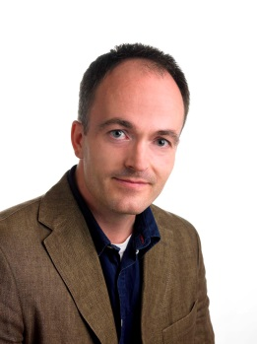**Speaker: Esben Rahbek Gjerdrum Pedersen**,Associate Professor and Director at cbsCSR.

Esben Rahbek Gjerdrum Pedersen is Centre Director and Associate Professor at the CBS Centre for Corporate Social Responsibility, Copenhagen Business School. His research covers corporate social responsibility (CSR), environmental management, and non-financial performance measurement. The results from his research have been published in a wide range of high ranked international journals. The research has been recognised internationally and been awarded with e.g. the 2010 Social Impact Award and the 2009 Emerald Literati Award.

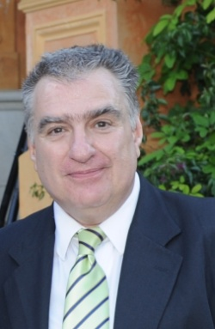**Speaker: Miguel Angel Gardetti**, Founder & Co-Director of Sustainable Textile Center.

Miguel Angel Gardetti,Ph.D. is co-founder and co-director of the Sustainable Textile Center and Head of the Centre for Study of Corporate Sustainability. He was "guest editor" (together with Ana Laura Torres) of two publications: first, in September 2012, a special issue of the Journal of Corporate Citizenship (UK) on "Fashion, Textiles and Sustainability", and, in March, 2013 a book on the same subject titled “Sustainability in Fashion and Textiles: Values, Design, Production and Consumption” (Greenleaf Publishing, UK).

**Speaker: Kirsi Niinimäki**, Post doc Researcher at Aalto University

Kirsi Niinimäki is a Post doc Researcher with Aalto University. In her research she opens a new holistic understanding in the field of sustainable design and the connection between design, manufacturing systems and consumption habits and accordingly, she is interested in sustainable design which includes future oriented value. She is also interested in research on strategically sustainable design, which is based on new green business thinking. Her publications include articles about textile and clothing consumption, person-product attachment, sustainable consumer satisfaction, empathic design and new sustainable design strategies and her articles have been published in e.g. Journal of Cleaner Production, Design Journal and Sustainable Development.



**Speaker: Dr. Ingrid Molderez**, Lecturer at HUB, Hogeschool-Universiteit.

Dr. Ingrid Molderez is lecturer in Corporate Social Responsibility and Economics at HUB, Hogeschool-Universiteit Brussel and researcher at CEDON, Centre for Corporate Sustainability. She completed her PhD at Hasselt University, researching sustainability and location, supervised by Professor Eric Lefebvre.

Ingrid’s research is focused on other ways of thinking about sustainability, thereby drawing on ideas and images from many sources such as art, language, literature, apart from organization theory, economics, social theory and philosophy. She has written on 'Other ways of thinking about the environment', 'Organisation as body-in-contact', 'Freedom and Uncertainty', 'Spirits of Ecological Thinking', 'The horizon’s embrace. A Faustian perspective on limits', 'The integration of competences for sustainable development in higher education'.

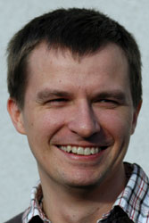

**Speaker: Robert Kudlak**, Researcher at RIMAS – Research Institute for Managing Sustainability

Robert Kudłak holds a doctoral degree in economic geography from Adam Mickiewicz University (AMU, Poznan, Poland). Between 2008 and 2010 he was a researcher at AMU, Poland. Since 2010, he has been a research fellow at the Research Institute for Managing Sustainability at Vienna University of Economics and Business. Currently, he is the leading researcher in the FP7-funded “IMPACT” research project investigating the impacts of CSR on economy, environment and society at large. Member of the Academy of Management. Research areas: Corporate Social Responsibility, corporate environmentalism, environment – competitiveness relationship, institutional approach to CSR.

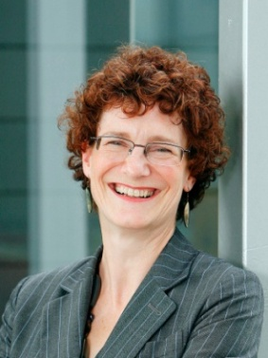**Speaker: Elizabeth Morgan**, PhD Fellow at University of Leeds.

Elizabeth Morgan is currently undertaking a PhD research at the University of Leeds, School of Earth and Environment. She previously worked for a large international consumer businesses, including as Marketing Director for Carlsberg Tetley and Global Product Director at Boots, the UK’s leading health and beauty retailer. Elizabeth now has a new career, researching at the University of Leeds and consulting on the opportunities and tensions for such businesses have as they seek to become more sustainable.

****Speaker:** **Rita Chang**, University of Delaware alumna, and currently the Vendor Capability Development Specialist at Nike, Inc.

Rita Chang earned her Bachelor's Degree at the University of Delaware, where she created her own major, "Social Responsibility in the Textile & Apparel Industry," and completed the UD Graduate Certificate in Socially Responsible & Sustainable Apparel Business after witnessing less than ideal working conditions during her first factory visit. In 2010, Rita moved to Taiwan to work in Nike, Inc.'s Considered Design team, where she managed a pilot project on the traceability of sustainable materials. Today, as the only Vendor Capability Development Specialist in the Sustainable Manufacturing & Sourcing team, she is responsible for training Nike's global materials teams and materials suppliers to engage in sustainability initiatives, most notably the Nike Materials Sustainability Index. Rita can easily spend hours on discussing the power of systems thinking, the impacts of culture on business decisions in sustainability, and the art of persuading others to do the right thing.

(Note: *The foundation of "Transformative Change in Social Sustainability Among Apparel Manufacturers" was written when the presenter was a student at the University of Delaware. The findings and conclusions in this research are solely those of the author and do not represent the views of Nike, Inc*.)

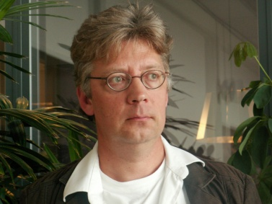**Speaker:** **H(arrie).W.M. van Bommel**, Senior-Lecturer at Saxion University of Applied Science.

H(arrie).W.M. van Bommel is a senior-lecturer/researcher at Saxion University of Applied Sciences in the Netherlands. As an academic engineer in Environmental Science he has been specialising on Sustainability and Business. Besides teaching he is working on a part-time PhD research project in cooperation with the University of Twente concerning the implementation of sustainability in global industrial supply networks using the fashion/clothing industry as case. Recently also involved in an ISWA (International Solid Waste Association) supply-chain project concerning the recycling of jeans.

**Speaker: Anika Kozlowski**, Designer and PhD. student at Ryerson University.

Picture of Karine

Anika Kozlowski is a designer and PhD. student in the Environmental Applied Sciences and Management program at Ryerson University. Her dissertation work specifically examines how the design process can begin to induce sustainable consumption behaviours through consumer engagement, innovation and sustainability-driven business models.

**Speaker: Karine Liotino da Silva,** Innovation and Sustainability Manager at the Brazilian Fashion Industry Export Program at the Brazilian Textile and Apparel Industry Association.

Picture on the way

Karine holds a bachelor in textile and fashion and master in management engineering at the University of São Paulo. She is Innovation and Sustainability Manager at the Brazilian Fashion Industry Export Program at the Brazilian Textile and Apparel Industry Association. Furthermore, she is Member of the Working Group on Innovation and Sustainability in Brazil Fashion System; Member of Innovation Committee of the Council of Competitiveness of the Textile, Garment, Shoes, Jewelry and Gems of the Ministry of Development, Industry and Foreign Trade; Committee Member of the INMETRO for Life Cycle of Products.

**Speaker: Tone Skårdal Tobiasson,**  journalist, author, lecturer and editor of NICE and Oslo Fashion Week Magazine.

Tone Tobiasson is a journalist, author, lecturer and editor of www,[nicefashion.org](http://nicefashion.org) as well as Oslo Fashion Week magazine. She was one of the founding members of NICE (Nordic Initiative Clean & Ethical) and coined the name. She travels extensively on behalf of NICE to talk about the issues surrounding environmental and ethical hurdles facing the industry, as well as to talk about some of the research projects she has been involved in, like Valuing Norwegian Wool and Textile Waste as a Resource.

**Speaker: Ingun Klepp,** Research Professor at the National Institute for Consumer Research in Oslo.

Research professor Ingun Grimstad Klepp wrote her MA and PhD on leisure time and outdoor life at the University of Oslo. She works at the National Institute for Consumer Research in Oslo with research on sustainable textile, fashion, clothing, laundry and leisure consumption. She has written numerous articles and books of these themes. She currently works with wool, both with consumption and questions regarding the value chain in Norway. For more information, please see homepage: [http://www.sifo.no/page/Staff//10443/48249-10600.html](http://www.sifo.no/page/Staff/10443/48249-10600.html)

<http://www.nicefashion.org/en/featured-projects/Wool/index.html>

Picture on the way

**Speaker: Claire Hamer,** Product Sustainability Manager at ASOS.com.

Claire Hamer is the Product Sustainability Manager at ASOS.com. Following 10 years buying for leading fashion retailers in the UK, Claire specialised in sustainable sourcing. During her career Claire has worked with businesses, government agencies and industry stakeholders to develop sustainable sourcing and trade development programmes. In her role at ASOS, Claire delivers a holistic programme that supports the business to create value through addressing sustainability sourcing challenges.